Analysis of Meteorological and Hydrological Droughts in the Kinnickinnic River Watershed, Wisconsin from 1983 to 2021

Christopher Archuleta

**Abstract**

The study presented here was assigned as part of a graduate-level watershed modeling and analysis course and focused on the Kinnickinnic River watershed in southeastern Wisconsin. Using data primarily from the National Water Information System, the National Map, and the PRISM Climate Group, this study was a way to investigate the hydrological and meteorological drought characteristics in the Kinnickinnic watershed. First, the Kinnickinnic watershed was delineated using hydrological and DEM data in QGIS. Then, the National Land Cover Dataset was used to classify the land covers in the delineated watershed in 2001 and 2021. The outputs from this part of the research project intuitively revealed a highly urbanized watershed with little change to other land covers in the past couple decades. Hydrological and meteorological drought analyses were conducted using R. Available daily precipitation and runoff data ranged from 1983 to 2021. This data was used in conjunction with specialized R packages and scripts to execute the Threshold Drought Method. Outputs from this part of the research project included statistics about drought duration and deficit, flow and precipitation drought threshold charts, scatter plots, and bubble plots. Major findings in this paper include a decrease in the largest meteorological drought deficits through the study period and no corresponding decrease in hydrological drought deficits. This amounts to an apparent decrease in synchrony between meteorological and hydrological droughts from the 1980s through the present.

*Keywords: Drought duration, drought deficit, hydrological drought, meteorological drought*

**Introduction**

Droughts are a type of environmental hazard characterized by an unusual lack of water. It is important to study droughts because adequate water is important for all forms of life and is key to society. Droughts can disrupt ecosystems, strain water resources, and stunt agricultural productivity (Choi et al., 2022). These negative impacts motivate humans to understand how droughts work, how to predict them, and how to deal with their effects. Those who study drought come from a number of disciplines such as ecology, hydrology, meteorology, agriculture, and geography (Choi et al., 2022). This indicates the complexity of the phenomenon as well as the urgency to understand it. Droughts are environmental hazards, and as such are fundamentally threatening to individuals and society at large, prompting research on them.

Although droughts are considered a type of natural hazard, they are influenced by human factors. Humans impact all parts of the hydrological cycle, inevitably shaping drought. Anthropogenic climate change has sweeping effects on hydrology throughout the world. Also, artificial changes to the landscape affect catchment dynamics (Choi et al., 2022). Population growth, especially in urban areas, presents local urban water management challenges (Montanari et al., 2013). The heavy reliance of urban populations on efficient water management is part of the reason drought research is important (Montanari et al., 2013). Good drought research takes human factors into account because they are not only natural hazards.

Within the broad category of droughts, there are two main types called meteorological and hydrological droughts. Meteorological droughts are defined by a lack of precipitation for an extended time (Choi et al., 2022). In other words, precipitation, the meteorological mechanism that brings water into surface and groundwater systems from the atmosphere, can become relatively scarce. When precipitation is insufficient for long enough, there are surface and subsurface effects such as decreased soil moisture and low streamflow (Choi et al., 2022). A lack of surface and subsurface waters, which results in reduced streamflow, is called hydrological drought (Van Loon et al., 2019; Choi et al., 2022). Meteorological droughts and hydrological droughts are characterized by lack of precipitation and lack of surface and subsurface water, respectively.

There is a connection between meteorological and hydrological droughts, but the connection can vary depending on local conditions and human factors. Meteorological droughts often propagate to hydrological droughts (Choi et al., 2022). Such connections can prove to be important for drought prediction and modeling. However, the connection to hydrological droughts is complicated, often manifesting after a lag period (Choi et al., 2022). Moreover, hydrological droughts tend to last longer than meteorological droughts (Choi et al., 2022). Finally, these connections depend on local conditions like climate, catchment type, and human activities (Choi et al., 2021; Van Loon et al., 2019). These particularities amount to differing levels of synchrony between meteorological and hydrological droughts (Choi et al., 2022). Extensive quantitative research on human impacts on hydrological droughts is relatively recent (Van Loon et al., 2019). Therefore, research projects focusing on both types of droughts at local scales is important, especially when looking at the strength and temporality of their connections as well as the human impacts on them.

This research project is a local study of meteorological and hydrological drought characteristics and relationships over the span of nearly four decades. The study is focused on the Kinnickinnic River watershed in the Milwaukee Metropolitan Area, where human factors are especially important. The study uses interpolated precipitation data and streamflow gauge data to analyze meteorological and hydrological droughts, respectively. The results of the research project reveal what appears to be a decrease in synchrony between the two kinds of drought over the course of the study period.

**Study Area**

This research project is about the Kinnickinnic River watershed in southeastern Wisconsin. The Kinnickinnic River originates several miles south and southwest of downtown Milwaukee, with the farthest upstream portions of the watershed located near General Mitchell International Airport. Water in this watershed ultimately flows northeast to the outlet of the river by downtown Milwaukee at a confluence with the Milwaukee River, about a kilometer upstream from Lake Michigan. Thus, the Kinnickinnic River is one of the three rivers of the City of Milwaukee. As part of the USGS Hydrololgic Unit Code system, the Kinnickinnic River watershed is a 10-digit watershed with the code 0404000305 (WIDNR, 2017). Although sources such as the Milwaukee Metropolitan Sewerage District (MMSD, 2023) say that the area of the watershed is around 25 square miles (65 square kilometers), the study area used in this project will be 47.556 square kilometers as described in the Data and Methods section.

The Kinnickinnic River is the most urbanized of the three rivers in Milwaukee. Most of the watershed is categorized as having urban land cover and almost half of the surfaces are impervious (MMSD, 2023). Notably, some of the streambeds of the Kinnickinnic River were replaced with concrete channels in the 1960s to increase stream velocity and reduce flooding (MMSD, 2023). Indeed, Figure 1 shows how little of the urban land cover in the watershed, as delineated for the project, has changed to other land covers in the past two decades. These characteristics show the importance of human influence on drought because impervious surfaces and channelized streams affect surface and subsurface flows. Clearly, humans can have an impact on hydrological drought in a study area like the Kinnickinnic River watershed.

*Figure 1: Land Cover Change of the Kinnickinnic River Watershed (2001*–2021)

**Data and Methods**

To investigate the meteorological and hydrological drought characteristics in the Kinnickinnic River watershed, the project involved an assignment for analyzing each drought type. Both drought types had a dedicated assignment in which precipitation and streamflow data were used to define droughts, visualize them, and statistically analyze them. For each type of drought, the primary metrics of interest were drought start dates, drought deficit, and drought duration. These drought characteristics were compared throughout the study period and between the drought types to look for synchrony and temporal trends. These main portions of the project were preceded by watershed delineation and land cover analysis, which were used to inform the study area portion of this report as well as the conclusions section. However, the goal of the research project, to understand the drought characteristics of the watershed, relied mostly on the two drought analysis portions of the project.

First, the watershed had to be delineated using stream data and elevation data. The watershed delineation took place in QGIS and used geospatial data. Conceptually, the watershed delineation requires an outflow point, stream data, and elevation data. The watershed is defined as the area where all of the surface and subsurface water share a common outflow point. In other words, watershed delineation works backwards from the outlet and entails finding all the places that drain to it. Stream data confirms the prevailing pathways water is actually taking on the surface. Elevation data is needed to derive surface flow characteristics, most importantly direction. This is why stream data and elevation data are used for delineating the watershed.

Data for the watershed delineation came from the National Hydrography Dataset, the National Water Information System, and The National Map from the. USGS. On the USGS website, one can find surface hydrology data, including the HUC-8 watershed containing the Kinnickinnic River HUC-10, as part of the National Hydrography Dataset and DEMs as part of The National Map. The datasets overlapping and corresponding with the Kinnickinnic watershed area were brought into QGIS. Then, the outlet of the Kinnickinnic watershed was defined using a USGS stream gauge near the outlet of the Kinnickinnic River. For this project, the site number was 04087159, called “Kinnickinnic River @ S. 11th Street @ Milwaukee, WI” (USGS, 2023). These three USGS datasets were used for delineating the Kinnickinnic River watershed.

A combination of typical GIS tools and specialized hydrology GIS tools were used to manipulate the stream and elevation data to delineate the watershed. DEMs were merged and clipped to the Milwaukee River HUC-8 watershed, which contains the study area watershed. Then the working DEM was filled. Filling the DEM is important when delineating watersheds because there can be data artefacts that include pits. When figuring out where water would flow using a DEM, pits divert water to places where they would not really go. Filling in pits creates a more realistic DEM. Next, the stream data was used a reference while delineating streams with a special tool that creates channels. The channels created from this tool were selected for significance using the fifth Strahler stream order as a threshold, resulting in delineated streams. Lastly, the upslope function works backwards from the outflow point to find contributing cells in the DEM. These steps in QGIS led to the delineation of the Kinnickinnic River watershed.

The newly delineated watershed was used to clip land cover data that was then reclassified to create a cleaner and simpler land cover depiction. As mentioned earlier, the watershed delineated for this project is 47.6 square kilometers, only 73 percent of the size given by most sources. However, this is probably mostly explained by the fact that the outflow point chosen is slightly upstream of the outflow point seen on most maps. Also, the general shape of the delineated watershed is very similar to the shape seen from credible sources like the Wisconsin Department of Natural Resources. Importantly, this means that conducting a simple land cover analysis using the delineated watershed is still reasonable because it is a fair representation of the official watershed. 2001 and 2021 land cover data from the National Land Cover Database was clipped to the delineated watershed. Then, using the official class legend and description, the number of classes was reduced for easy comprehension. As a result, most of the watershed appears as simply “Urban” in both 2001 and 2021, which is why Figure 1 shows very little change during that time period.

After the watershed delineation and land cover analysis tasks, the project consisted of meteorological drought analysis and hydrological drought analysis in R. Specialized scripts for drought analysis were brought into an R project and ran to produce statistics and charts about droughts. In the end, these steps led to the results of the research project, namely the drought characteristics from 1983 to 2021. These drought characteristics included time of start, duration, and deficit. Statistics for these drought characteristics were done using R.

The meteorological drought analysis used daily precipitation data from the PRISM climate group. The assigned time period for both drought analyses was from January 1, 1981 to December 31, 2022. However, the data was incomplete for three of the years, leading to a study period from January 1, 1983 to December 31, 2021. The PRISM dataset is split into cells, and downloading precipitation data requires the user to select a location, which falls within a particular cell. The data for meteorological drought analysis is an interpolated daily precipitation time-series from the PRISM Climate Group.

The precipitation data was added to an R script that output meteorological drought statistics and charts. The first major purpose of the R script was to calculate a variable threshold. Variable drought thresholds are based on exceedance probability, but for a specific time such as a day in the year. Using this threshold, the script calculated drought characteristics. Drought characteristics are then used to make tables and plots, some of which are shown in the Results section. With just the threshold, there is no limit to how small a drought deficit or how short a drought can last. Furthermore, using only a threshold to define droughts can undermine long periods of drought with brief periods where the precipitation goes above the threshold. To address these quirks, there are scripts that pool drought events if the inter-event time period is less than 10 days and remove drought events if they last less than 15 days. This creates new drought characteristics that can be plotted and tabulated. These are the main functions of the R script for analyzing meteorlogical drought.

Data used for the hydrological drought came from the National Water Information System. This is a series of stream gauges that have unique identification numbers. Like the precipitation data, users can obtain daily time-series data from USGS stream gauges. The dates used for the hydrological drought range from January 1, 1981 through December 31, 2022. Admittedly, it would have been more appropriate to have used the same dates as the ones used in the meteorological drought analysis. The mismatch in the dates means that direct comparisons of summary and aggregate statistics are not ideal. This was a personal oversight and not intentional. Furthermore, the main findings of the research project pertain to the data trends more than the summary statistics, which are merely the result of precipitation being higher in magnitude than streamflow. Regardless, the data used for the hydrological drought analysis came from USGS stream gauge data from 1981 to 2022.

Runoff data was added to R for hydrological drought analysis, using a very similar script to the one used for meteorological drought analysis. Like the first script, the script used here calculated a variable threshold, pooled drought events, calculated drought characteristics, and generated plots and charts. The difference is that the outputs from this script approach drought as a function of streamflow rather than precipitation. Overall, the broad tasks completed by the two R scripts are the same, but they were repurposed for different drought analyses.

After this main portion of the research project, the data were used to model the Kinnickinnic watershed. This step used airGR packages through R, which are specially made for hydrological modeling. Like the other R scripts, the R script for this portion outputs visuals and statistics. However, the outputs are more interactive through airGR and hydrology charts are plots are generated in bulk. Such plots include time-series plots and flow duration curves. This method was the most self-contained and as such there is not much to say about it in this section, but it was part of the overall watershed project.

**Results**

The outputs from the R scripts constitute the main results for this drought analysis project, and they mainly indicate a decrease in synchrony between meteorological and hydrological droughts.

Table 1 shows four summarized drought characteristics for both drought types. Unsurprisingly, the deficit values are higher for meteorological drought. The average durations are similar for both, but the maximum duration ratio is about 5/6.

*Table 1: Drought characteristic statistics for both drought types, aggregated by entire study period for each type*

|  |  |  |
| --- | --- | --- |
|  | Meteorological Drought | Hydrological Drought |
| Average Duration | 28.96 days | 32.25 days |
| Average Deficit | 19.60 mm | 7.14 mm |
| Maximum Duration | 121 days | 100 days |
| Maximum Deficit | 124.69 mm | 31.65 mm |

Probably the most insightful charts created during the project were the bubble plots. The bubble plots were created in the drought analysis R scripts and depict three variables. The x-axis is time, specifically the time of a drought start. The y-axis is drought deficit. On the chart are bubbles whose size represent drought duration. These plots were created using the ggplot package. The bubble plots were insightful not only because they display three drought variables, but also because there are visible differences between the one for meteorological drought and the one for hydrological drought.

Figure 2 shows the bubble plot for meteorological drought. The high deficit outliers decrease in size through the study period. There are four drought deficits over 50 mm within the first fifteen years of the study period, but only two for the remaining 25 years. Moreover, three of the outliers from the first fifteen years are larger than either of the two in the latter 25 years. This shows an apparent decrease in meteorological drought deficit outliers from the 1980s through the 2010s.

Figure 3 shows a different trend, which is the bubble plot for hydrological drought. The deficit outliers have a more constant appearance, not necessarily changing over time. This seems to indicate that larger hydrological droughts are not trending the same way as meteorological droughts in the watershed.

*Figure 2: Bubble plot of meteorological drought start date, deficit, and duration in the Kinnickinnic watershed from the early 1980s to the early 2020s*

*Figure 3: Bubble plot of hydrological drought start date, deficit, and duration in the Kinnickinnic watershed from the early 1980s to the early 2020s*

One of the key drought periods in the recent history of the area was in the early 2010s, and this research project produced drought plots focused on those years that possibly show longer hydrological droughts during this time period. Figure 4 shows meteorological droughts with precipitation values against the variable threshold, with the droughts colored in red. Figure 5 similarly shows hydrological droughts as red areas where flow goes below the variable threshold. Comparing these charts seems to show that the hydrological droughts during this time lasted longer than the meteorological droughts.

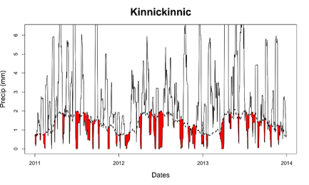

*Figure 4: Meteorological drought plot of the Kinnickinnic watershed from 2011 through 2013 with variable threshold*

*Figure 5: Hydrological drought plot of the Kinnickinnic watershed from 2011 through 2013 with variable threshold*

Charts produced by the airGR package are shown in figures 6 though 8. The same precipitation and flow data used in the rest of the project were used to calibrate and test the model. The NSE value for the model calibration was 0.3, which is acceptable but not ideal or satisfactory by any means. Similarly, the simulated streamflow values in the flow duration curve deviate from the observed streamflow values for lower flows. Specifically, the smallest simulated flow values were too large. The non-exceedance probability was too high for flows up to 1 mm/day. However, these issues with the simulation were expected because the best parameters for modeling were not determined.

The plots below show how the simulated streamflow were consistently higher than the observed streamflow. These results make sense for drought conditions. The calibration period conditioned the model to have parameters reflecting less anomalous streamflow than what occurred in the simulation period. In other words, calibrating a model using limited data keeps it from predicting extreme conditions such as droughts. However, if the model would have been calibrated to more closely match the low flow probability then it would have approximated drought conditions better.

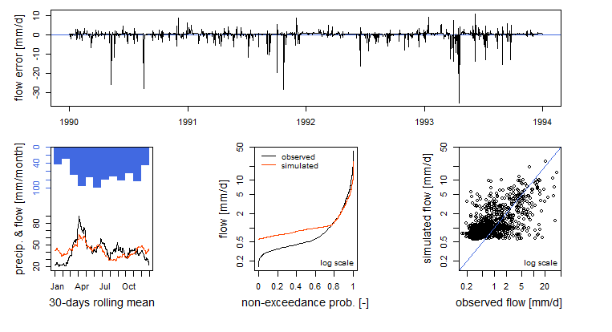*Figure 6: “Perf” calibration plots, using airGR package with calibration period from 1990-1993*

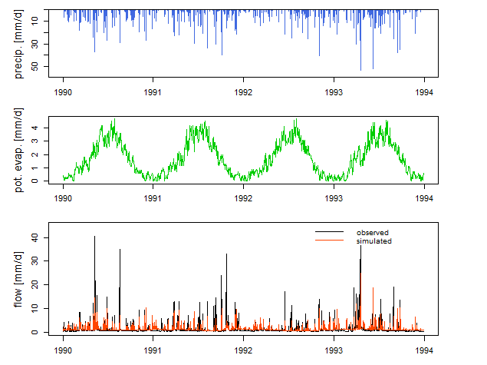 *Figure 7: Time series calibration plots, using airGR package with calibration period from 1990-1993*

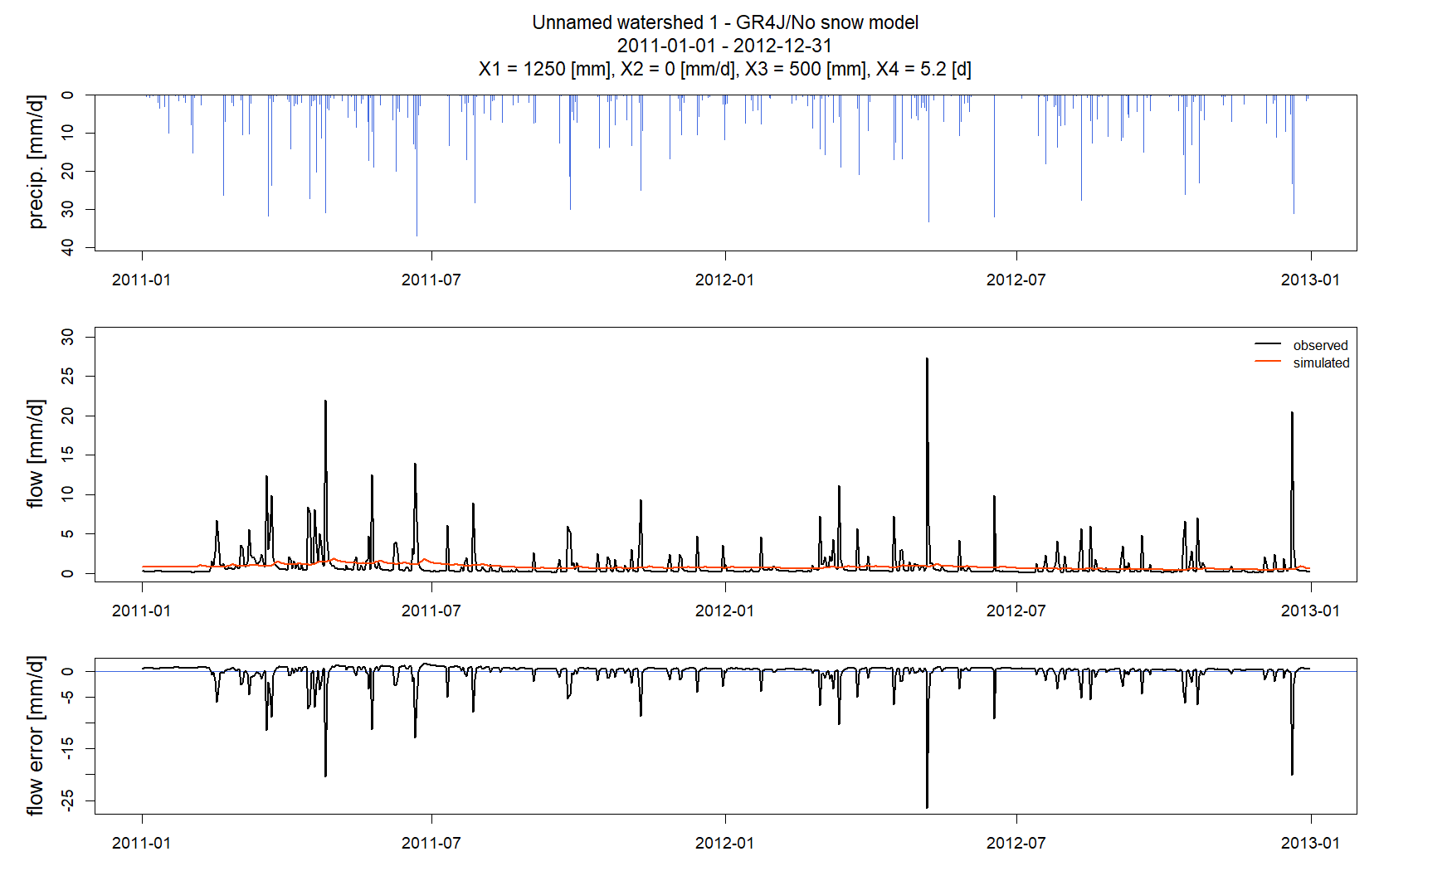 *Figure 8: Model prediction charts, backtesting on period from 2011-2012*

**Conclusions**

This research project was a fairly reasonable approach to analyzing two kinds of drought for a particular watershed. There were things taken into consideration such as data artefacts, seasonality, and statistical significance. Given more time, some of the preliminary findings mentioned in the Results section would be tested for significance. Regardless, this project hints at some of the already established discoveries of the need to study droughts locally, to understand how hydrological droughts can diverge from the trend of meteorological droughts, and how droughts can be analyzed with human factors in mind. This project focused on a unique watershed known for its artificial channels and impervious surfaces, and the results seem to show that the two kinds of droughts do not always synchronize or correspond with each other.

**Drought Script Readme**

TOTAL SCRIPT:

- Drought_total.r: Script to calculate a threshold, do drought analysis and plot droughts

OR SEPERATE SCRIPTS:

(use if you want to use other data (e.g. other catchment / other time period) to calculate threshold or if you only want to execute part of the script with pre-saved data)

- Threshold.r: Script to calculate a fixed or variable threshold from duration curves and write to file (if threshold level is pre-determined, skip this, and make threshold file manually)

- Drought_analysis.r: Script to calculate drought charactersitics from threshold and write to file

- Drought_plots.r: Script to plot droughts & drought charactersitics with threshold (can also be done after pooling)

- Drought_pooling.r: Script to pool droughts & remove minor droughts

- Drought_characteristics.r: Script to calculate average & maximum drought characteristics (can be done on pooled/unpooled droughts, with minor droughts in/out)

FUNCTIONS:

(functions need to be in same directory)

- Threshold_functions.r

- Drought_functions.r

- Pooling_functions.r

- Characteristics_functions.r

For information about the threshold level method, please refer to Van Loon, A.F. (2015). Hydrological drought explained. Wiley Interdisciplinary Reviews: Water, 2(4), 359-392.

**References**

Choi, W., Borchardt, S. A., & Choi, J. (2022). Human influences and decreasing synchrony between meteorological and hydrological droughts in Wisconsin since the 1980s. Annals of the American Association of Geographers, 112(1), 36-55.

MMSD. (2023). Kinnickinnic River. <https://www.mmsd.com/what-we-do/flood-management/kinnickinnic-river>.

Montanari, A., Young, G., Savenije, H. H. G., Hughes, D., Wagener, T., Ren, L. L., & Belyaev, V. (2013). “Panta Rhei—everything flows”: change in hydrology and society—the IAHS scientific decade 2013–2022. *Hydrological Sciences Journal*, *58*(6), 1256-1275.

USGS. (2023). https://waterdata.usgs.gov/nwis/inventory/?site_no=04087159

Van Loon A.F., Rangecroft S., Coxon G., Brena Naranjo J.A., Van Ogtrop F., Van Lanen H.A.J. (2019). Using paired catchments to quantify the human influence on hydrological droughts. Hydrol. Earth Syst. Sci. 23(3), 1725-1739.

WIDNR. (2017). https://data-wi-dnr.opendata.arcgis.com/